Purpose
The purpose of this Quick Rerence Guide is to describe and demonstrate how to submit an EITSM ticket through:
- the Self-Service portal; and
- Assyst.

Self-Service portal

To request software or hardware through AUTODESK in the Self-Service portal navigate to the EITSM launch page: http://eitsm-gstie.forces.mil.ca/web/ie/welcome
- Select Self-Service Portal
- Select Service Catalogue
- Select Applications, Database & Licensing Services
- Select Enterprise Applications Software
- Select Report an Enterprise Business Application Incident.

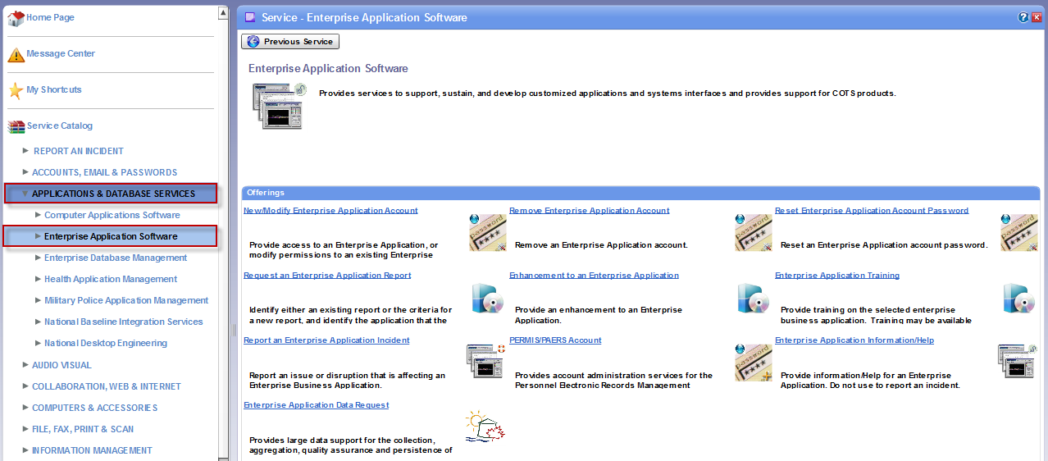

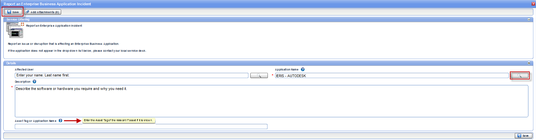

- Affected User: your name will auto-populate. If submitting a ticket on behalf of another user, enter their name. Use the DWAN structure for entering the name.
- Application Name: IERIS - AUTODESK
- Description: Describe the software or hardware you require andn why you need it.
- Asset Tag or Application Name: Enter the Asset Tag of the relevant IT asset if it is known.

- You can add attachments if you want using the “Add Attachments” button. Otherwise, press the Save button.

Assyst

** Note: only certain users have access to Assyst. **

To request software or hardware through AUTODESK in Assyst navigate to the EITSM launch page: http://eitsm-gstie.forces.mil.ca/web/ie/welcome and select EITSM (assyst).

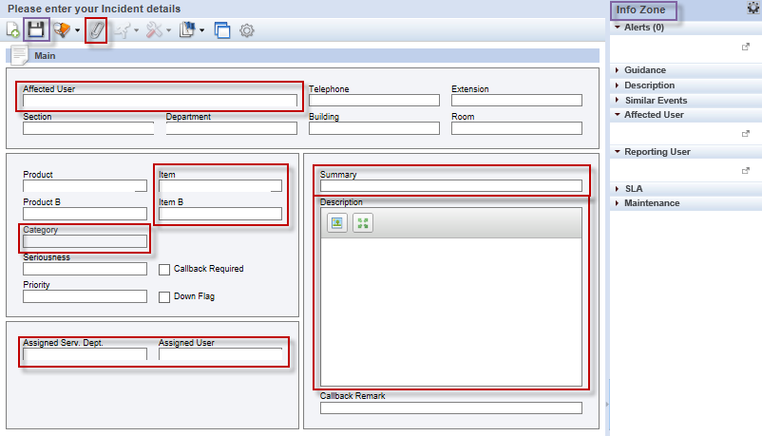

- Affected User: name (same as DWAN structure). This is the only field pertaining to the user’s contact details that needs to be populated manually. The user’s DWAN information will auto-populate the remaining user details and the Info Zone.

- Item: Software – Enterprise Application
- Item B: IERIS-Autodesk
- Category: Other

- Assigned Serv. Dept: erase whatever pre-populated when you selected Category. Type ENT-App Support.
- Assigned User: Phan.T

- Summary: select the Incident description based on the template used by the IEBDS Service Desk, ex. Autodesk.
- Description: free text field to enter description / details of request. If the request came into the positional mailbox, please copy and paste the email into the Description field. If it was a phone call, describe as best you can the user’s issue(s).
- Click the Paperclip to attach files. Use this to attach the user’s original email. (The original email should be attached for, at the very least, informational purposes.)

Click the Save icon to save the incident.

The client will automatically receive an email notification that their ticket has been created. They can track their ticket through the EITSM Self-Service portal.

END OF DOCUMENT

